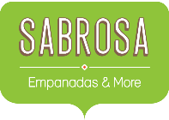
Service Invoice
PO Box 4554 • Chicago, IL 60611
312-555-8282

Category Amount
Menu Food Items $828.45
Beverage Items $315.50
Paper Items (Plates, silverware, cups) $135.15
Rental Equipment (Tables, chairs, linens) $277.75
Labor cost (3 servers and 1 preparer) $192.00
Service Fee (18% of menu items ordered) $149.12
Total $1,897.97

Day | Hours at Location | Items Sold | Total Receipts
Monday | 4 | 62 | $374.28
Tuesday | 3 | 28 | $115.19
Wednesday | 2 | 32 | $202.87
Thursday | 2 | 21 | $85.85
Friday | 5 | 115 | $624.39
Saturday | 5 | 228 | $1,401.03

