

Pool Re-Opening & Celebration
1000 Lake Sylvan Boulevard | Orlando, FL 32804 www.limegroveapts.com A Buena Vida Community

Spring 2013 Newsletter
Spring 2013 Newsletter

Join us Saturday, April 7, to celebrate the grand re-opening of our newly renovated pool!
Features include a resort-style pool deck, private cabanas, gourmet grilling area, and much more. We can’t wait for you to see the transformation!
The celebration will last from dawn ‘til dusk. (After that, it’s up to you!) Fruit, lemonade, slushies, and other cool treats will be served from 1:00-2:00 PM.
Memorial Day Barbecue
Mmmm! It’s that time of the year again! Time to gather up the kids and come on down to the pool for our annual Memorial Day Barbecue. This year, our Memorial Day buffet will be catered by Ralph’s Simmerin’ Barbecue and Slaw. It’ll happen rain or shine!
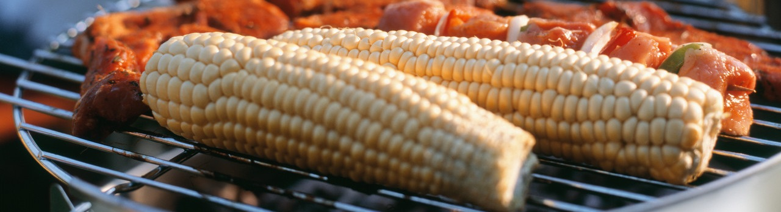
This year’s barbecue is scheduled on May 27th from 12:00 – 4:00. Come hungry!

